Project Planning Phase

Sprint Delivery Plan

|  |  |
| --- | --- |
| Team ID | PNT2022TMID04422 |
| Project Name | Personal Expense Tracker |

**TOOLS USED:** JIRA

**ROADMAP:**

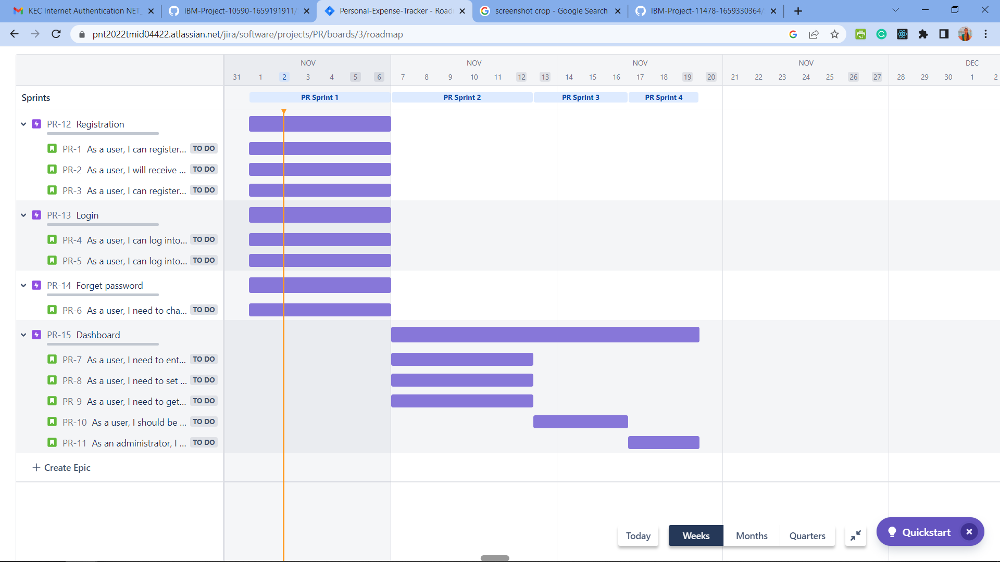

**BACKLOG:**

